8 Run Collection with Collection Runner



This section will guide you to understand:

* How to run Collection through Collection Runner
* What are the responses

**Development Environment**

* Postman Tool
* Endpoint URL

This guide has three subsections, namely :

2.8.1 Working with Collection Runner

2.8.2 Running Collection Runner

2.8.3 Pushing the code to your GitHub repositories

**Step 2.8.1:** Working with Collection Runner

There are two ways to run a collection which is the Collection Runner and Newman.

Let's begin by executing the collection in Collection Runner.

* Click on the Runner button found at the top of the page next to the Import button.

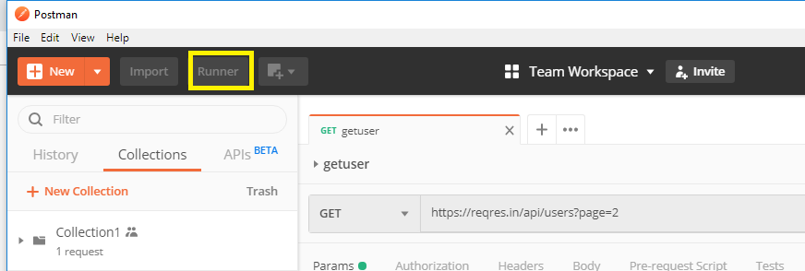

* Collection Runner page should appear as below. The following is a description of the various fields:

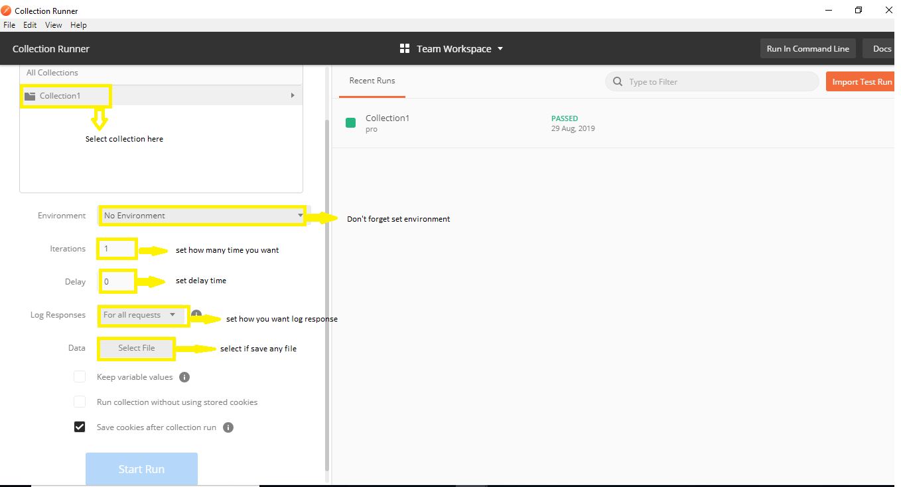

**Step 2.8.2:** Run Collection Runner

* Choose **Collection1**: Set iterations as **3**
* Set delay as **2500 ms**
* Click on **Run Collection1** button

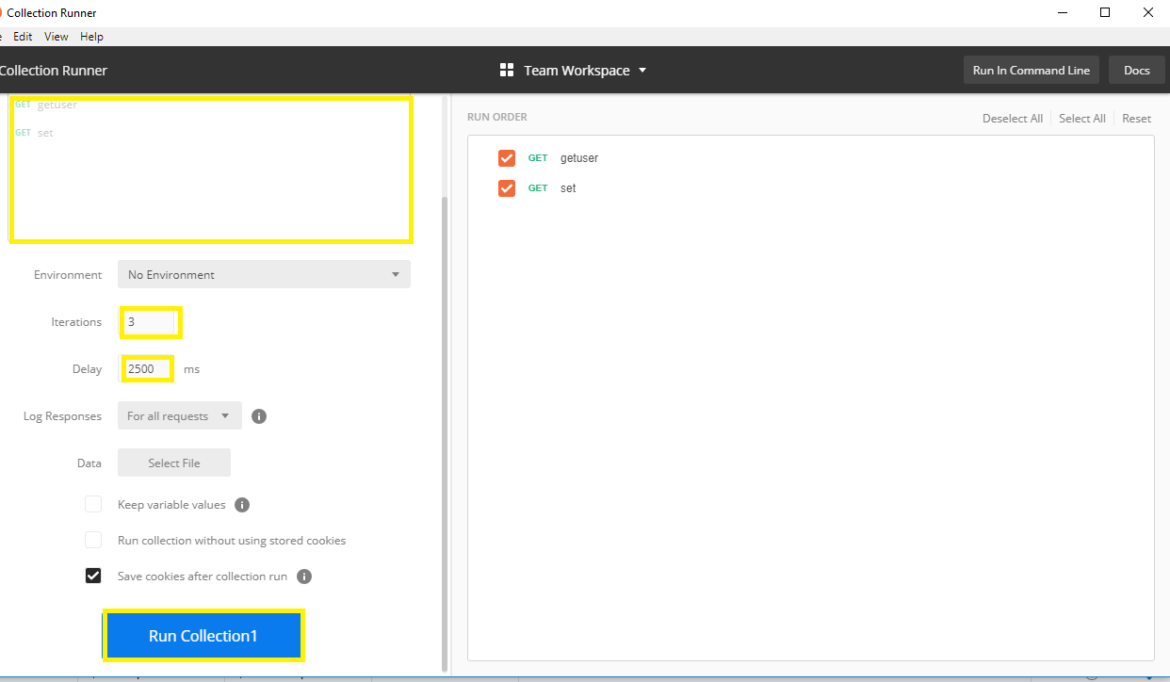

* Run Results page should be displayed after clicking the Run button. Depending on the delay, you should see the tests as they execute.
* Once the tests have finished, you can see the test status if it is **Passed** or **Failed** and the results per iteration.
* You see **Pass** status for the Get Requests.
* Since we did not have any tests for Post, there should be a message that the request did not have any tests.

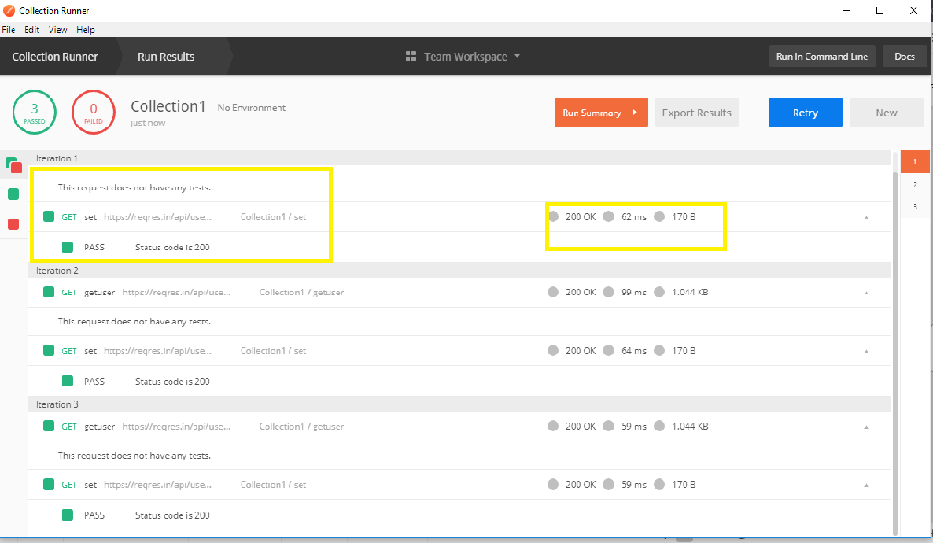

**Step 2.8.3:** Pushing the code to your GitHub repositories

Open your command prompt and navigate to the folder where you have created your files

cd <folder path>

Initialize your repository using the following command:

git init

Add all the files to your git repository using the following command:

git add . 

Commit the changes using the following command:

git commit . -m “Changes have been committed.”

Push the files to the folder you initially created using the following command:

git push -u origin master